The “A” Team – Vocabulary List / Name _______________________________
- Use a dictionary to find definitions for the following terms. There will be a quiz on Thursday.
- Select your TWO most difficult terms and create trading cards to help with comprehension.
- Trading card guidelines include the term and a definition, use it in a sentence, and sketch an image that will help you remember the meaning of the word.
- Use the remaining 13 terms in a sentence.

abnormal – not normal, average, or typical.
abode -- ______________________________________________________________________________
abrupt -- _____________________________________________________________________________
accelerate -- __________________________________________________________________________
acclaim – To welcome with joy and applause.
acknowledge -- ________________________________________________________________________
acquire -- _____________________________________________________________________________
aspire -- ______________________________________________________________________________
addict – a person who is psychologically dependent upon an activity or habit.
adjacent -- ____________________________________________________________________________
agitate -- _____________________________________________________________________________
annihilate -- ___________________________________________________________________________
anonymous -- _________________________________________________________________________
antagonize -- __________________________________________________________________________
apathy -- _____________________________________________________________________________

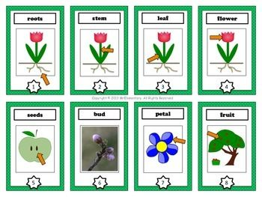

Definitions, sentences, and trading cards are due on Thursday, October 16, 2014.

